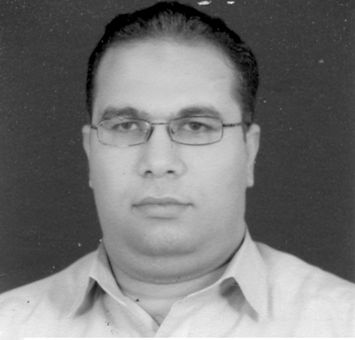
Curriculum vita
Personal information
Name: Nasr Taha Hassan
Occupation: lecturer in accounting department, Benha University
Date of birth: 16-1-1973
Birth place: Cairo
Current address: 1 Awqaf Street- Benha city- Egypt
Marital status: married
Driving license: valid
Military service: finished
Telephone: Egypt: 0143527633 – KSA: 0564854114
E-mail: nt_hassan@yahoo.com

Educational Qualifications
- 2006-2010: PHD degree (doctor of philosophy in accounting) from Durham business school, Durham University, UK.
- 1999-2003: master degree from Benha University in cost accounting.
- 1995-1997: two years studying pre-master courses at faculty of commerce, Benha University. These courses are;
- Financial accounting
- Cost accounting
- Managerial accounting
- Accounting information systems
- Tax accounting
- Operations research
- Studies in national and governmental accounting
- Computer application and information system
- Accounting theory
- Studies in special accounting
- Economics of the project
- Methods of scientific research
- Seminars
- 1990-1994: b.sc. Degree from accounting department, Benha University with a general grade very good.
- 1978-1990: primary and secondary school.

Professional Qualifications
Occupying the job of a demonstrator in accounting department for 8 years (1995-2003), and the job of an assistant lecturer for 7 years (2003-2010). I have 9 years (1997-2006) experience in teaching accounting and management courses such as principles of accounting, intermediate accounting, management accounting and tax. I have 4 years (2006-2010) experience in teaching accounting courses, invigilation, and students’ registration system in Durham University. Currently, I am an assistant professor in Salman bin Abd-Alaziz University in kingdom of Saudi Arabia.
Training courses
Egypt (Benha University)
- three training courses concerning developing skills of academic staff in the university:
- effective show skills
- effective communication
- using technology in teaching
- training courses concerning computer applications programmes such as PowerPoint, Excel and Word
England (Durham University)
- Some training courses concerning process of academic research:
- Introduction to Nvivo
- Library-discovering databases: the published literature (social science)
- Library-discovering databases: the wider electronic environment (social science)
- managing your research project 1. Introduction
- managing your research project II. Effective communi9cation
- introduction to Endnote
- sentence structure workshop
- common language errors
- some training courses concerning information technology:
- an introduction to spreadsheets using Excel 2007
- further Excel 2007
- an introduction to PowerPoint
- word for thesis writing

Skills
- Language:
- Mother language is Arabic
- English language is very good
- I have passed international toefl test with score of 550.

- Computer:
- I have ICDL
- I am perfectly using word and power point application
- I attended courses in word, access, excel and power point applications in both Egypt and UK.
- Other: my empirical study for PHD degree contained;
      - Analysis annual report for FTSE 100 companies in 2005 and 2006
      - Collecting data about corporate ownership, corporate governance and some financial data

Research Interested
New techniques in managerial accounting such as TQM, ABC, JIT and outsourcing.
Corporate social responsibility disclosure and corporate governance. Analysis Quality of disclosure
Publications
Nasr Hassan, Suggested framework for determinants of corporate social responsibility disclosure, paper presented in 12 ^{th} financial reporting and communication conference, Cardiff, 2008.

